Prepare your setup

On control server

# yum install epel-release -y

(This release has more versions in it and you will get ansible 2.3 and above)

# yum update -y

(To update our local caches)

# yum install git wget vim python python-devel python-pip openssl ansible -y

(Will install packages and dependencies and are installing python because ansible runs playbooks and some modules which are written in python and in detail will be covered in ansible configuration and management course)

# ansible --version

(To check the version)

There are some configuration changes in quick start in the configuration file in order to get started with ansible.

# vim /etc/ansible/ansible.cfg

(The ansible configuration file lets go and edit)

Will go the Default section and edit some changes: -

Will just uncomment as shown in the below image for inventory and sudo_user

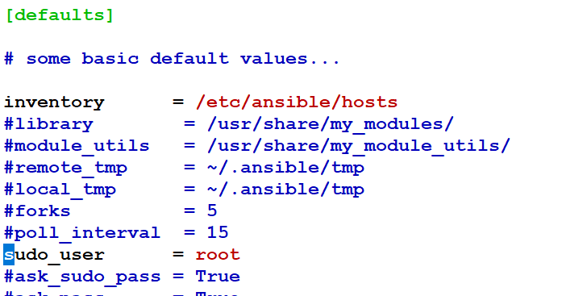

Sudo_user why we are uncommenting is because whenever we use sudo that will work as a root user.

Inventory is to determine that to look on certain hosts local file and in this case we will have globally available host file.

In ansible there is no daemon running to restart after the configuration changes in the file. Ansible will read its configuration file every time you made changes.

Before editing the original file please move that to a new file

# mv /etc/ansible/hosts hosts.original

Ansible finds its nodes by names or dns names or values that are listed on hosts file

# vim /etc/ansible/hosts

Here wehave to set up groups and they are identical by brackets [ ]

Ex: - hostnames for our nodes are Server-controlserver, centos-node1, ubuntu-node2

Our configuration file looks like: -

[localhost]

controlserver

[centos7]

centos.iselglobe.com

[ubuntu1604]

ubuntu.iselglobe.com

Save ad exit the file :wq!